PritiX

Application Guidelines

Main Modules

* **Login**
  + User should have login to their account.
* **Dictionary**
  + Create/Edit/Delete dictionaries
* **Tests**
  + Test their learning by doing self-assessment tests.
* **Admin**
  + Manage whole website content and users by admin panel.

Application Architecture

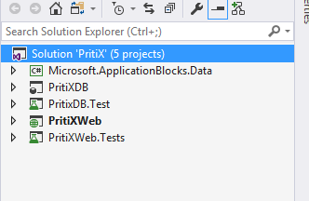This application contains 4 main projects.

* PritiXDB  
  Database project for creating database   
  on the fly for application. Deployment   
  of database related changes should be   
  build and deployed by automated builds.   
  This include Pre and Post deployment   
  scripts which will insert sample values in  
   the tables created by db project.
* PritiXDB.Test  
  Unit test coverage for all database   
  objects like Stored Procedures, Functions   
  Views. This will check code quality of   
  database and keep database in healthy  
  and deployable state.
* PritiXWeb  
  This is the Main application which contains all the asp.net forms and bootstrap implemented for better user experience for Laptop and mobile devices.
* PritixWeb.Test  
  Unit test cases for all the classes and their methods. Microsoft unit test framework is used to create these test cases.

How to Build Application

Open solution and right click on **PritixDB.Publish.xml** and select open with XML editor.

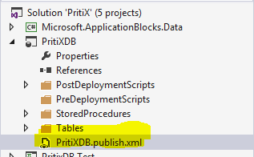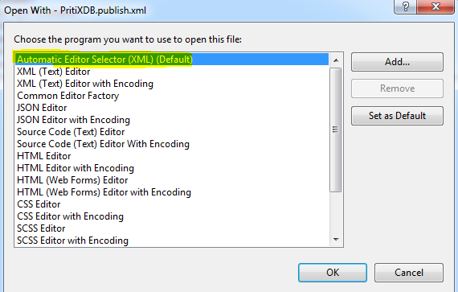

Change TargetDatabaseName and TargetConnectionString to your localDB environment.

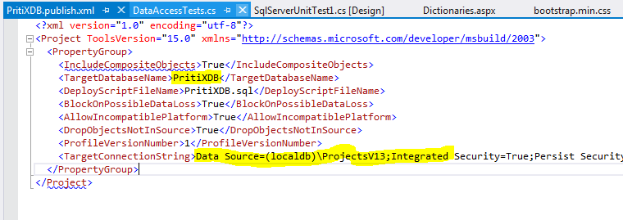

Change connection string PritixWeb Application web config file to connect to Localdb environment that will be created by PritiXDB project.

